Guru Maharaja Addressing the World Situation

Croatia Retreat 2016, 1st June 2016, Island of Iz, Morning Session

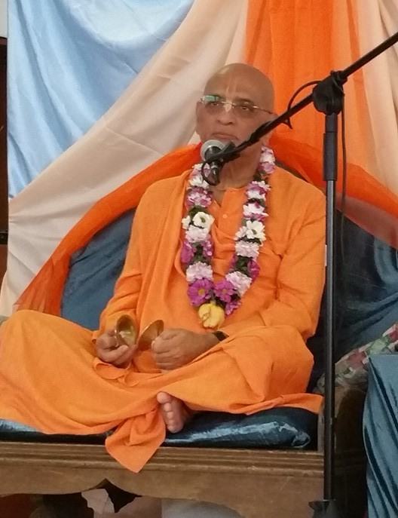

Yesterday many of you were not here when after the Harinama we came back. I was speaking briefly and I was pointing out the importance of this congregational chanting of the holy name. Not only because it is the yuga-dharma; in this age nothing else is going to work. Meditation won’t work. Fire sacrifice won’t work. Just worshipping the Deity in the temple alone won’t work. What will really matter? *Kalau nasty eva nasty eva nasty eva gatir anyatha*. Anyatha means other than. Other than this congregational chanting of Hare Krishna there is no other way. So that is what we have to understand. There is no other way. So that is what matters. This is the only thing that will matter.

And I was elaborating on what this actually means and I was explaining the world situation is becoming so critical, so precarious. Does the world situation seem to be very pleasant now? Although we are leading quite a comfortable life, the situation is very precarious. Any day, everything will be finished. Just consider, millions of refugees are coming from Syria and Iraq. Millions of them. They are destitute, they don’t have any place to stay and so many of them must have been living in mansions but today they are destitute, they don’t have any place to stay. So this is how uncertain our situation is. Any day anything can happen. Today I am living in a palace, tomorrow I may even not be able to even stay under a tree. That is how uncertain the situation is.

The world is becoming extremely frightening. We are seeing what is happening. Who could ever think that somebody could just come and blast a suicide bomb in an airport where people are just standing in the cue to board, to get into the plane. People are just standing in the railway station, subway station, so many people. In Karachi people were celebrating Easter – not that these people were all Christians, most of them were actually Muslims. The Muslims came and blew them up, 130 people dead. The official declaration is 130 people – who knows how many actually died? In these gatherings one bomb will wipe out whoever is there within the radius of at least 30 meters. Can you imagine within 30 meters on an occasion like that how many people must have died?

So this is how precarious, how dangerous the situation is. Now tell me what is the shelter? Is the army going to protect us? Is the police going to protect us? Is the government going to protect us? All these governments are shaking. They know that they are in a very, very difficult position. And the army thing is just a joke. I was thinking, in France when this thing happened, the blast in Paris, the army was guarding the schools, but I was thinking for how many days they are going to guard? For how many days you can deploy the army to just guard the schools? One week? Two weeks? A maximum of one month? But then what will happen? Is it only the schools that the suicide bombers can attack? They can blow themselves up in the middle of the street! What is the army going to do? You have noticed the army, police, the whole system will become totally ineffective.

This is the situation, so what is the shelter? Srila Prabhupada showed us the shelter, what is the reality and what is the effect of that shelter. In 1944 Calcutta was about to be bombed by the Japanese, because Calcutta was the biggest military base of the British. So they were going to bomb that area. So naturally people were evacuated. One of Srila Prabhupada’s godbrothers also was staying at Srila Prabhupada’s house at that time and he decided to go to Navadvipa, and he asked Srila Prabhupada, “Aren’t you going to go?” Prabhupada said, “No, I’ll stay here. I won’t go anywhere.” And he said what will you do and Prabhupada replied, “I will go out on a Harinama.” And Prabhupada did take out a Harinama. Prabhupada’s point was, “If I chant the holy name, Krishna will protect me, and even if Krishna doesn’t protect, if I leave my body chanting the holy name I will achieve my perfection.” So either way it is a win-win situation. Either way it will be beneficial. And the ultimate consideration is, for some unknown reason, Japan decided not to bomb Calcutta. Now, to them it may have been unknown, but we know the reason: because Srila Prabhupada chanted the Hare Krishna Mahamantra congregationally in the city, it was saved. So this is the potency of the holy name.

We should be fearless: we have taken shelter of the holy name, will Krishna protect? Now somebody may say, “Well, what if we die?” Maybe somebody will die, but what will Krishna protect? Will Krishna protect the body or will Krishna protect the soul? [audience: the soul] We have to have that full conviction that Krishna will protect the soul. Whether the body goes or not, it is not important. When we go to a doctor do we expect that the doctor will save our shirt? On the other hand, to operate on us, the doctor cuts open that shirt. When there is an accident he’ll just tear off the shirt and gets into the wound. So just as a doctor’s business is not to protect the shirt or the dress, Krishna’s business is not to protect the body. He may protect the body, it doesn’t matter. What is more important: saving the body or saving the soul? [audience: the soul] So will Krishna protect us? [audience: yes]

And Krishna may change the situation. Krishna may even change the situation. Like, in the Bible there is a statement, God was about to destroy Sodom and Gomorrah, but He mentioned that if there is one pious soul, that means if there is one devotee, He will not destroy the city. That brings up another point: how precarious the world situation is. You know why the Lord wanted to destroy Sodom and Gomorrah? Because homosexuality was going on there. From that came the word “sodomy” (homosexuality). Sodomy, from Sodom. And today governments are legalising sodomy, same sex marriage. That shows how sinful the world has become. Do you think that God is going to save this world? I mean, He is terribly upset. He is simply not destroying because Krishna Consciousness is spreading. Just because Krishna Consciousness is spreading, Krishna is giving a chance. If Krishna Consciousness continues to progress, then He will protect us, otherwise a massive destruction will take place.

I think about 25 years back I got to know that the world has enough nuclear weapons to destroy the world three hundred times. So this is the situation. We are sitting on a? [audience: time bomb] So that is the world situation. That is how powerful these weapons are, the weapons of mass destruction. You know of the atom bombs destroying two cities, Hiroshima and Nagasaki. So now the kind of nuclear weapons that we have, compared to those weapons, those atom bombs are like toys. Those toys destroyed two cities, and what they have today – can you imagine how devastating it can be?

Are you worried? Are you afraid? [Audience: no] Just rejoice. Hare Krishna Hare Krishna Krishna Krishna Hare Hare / Hare Rama Hare Rama Rama Rama Hare Hare. And mind you, when we face the situation in this way, then only people will recognize the importance of this Movement, the power of this Movement. They will see that these devotees have conquered death. Then only will they take Krishna Consciousness really serious. Now people laugh at us, “Oh, Hare Krishna people.” They don’t know what Hare Krishna really is. When you looked at the Hare Krishnas before you joined, what did you think of Hare Krishna? Didn’t you think they were a bunch of weirdos? And today you yourself became one. [laughter] Why? Because you saw its real value.

So from a distance one cannot really make out unless and until one gets to see what it really is. And won’t it be amazing when devotees would behave like Haridasa Thakura? “Okay, you want to kill me? Kill me! But I’ll continue to chant the holy name.” Didn’t we learn that from Prahlada Maharaja? “You want to kill me? Kill me, who cares? I am going to just take shelter of Krishna.” And that will be the real purification of the heart. Only when our heart becomes completely purified then only will can display this kind of dedication towards the holy name. So let us rejoice that we have the most precious gift.